Use-Case Realization Report
DeleteDap

Issue <1.0>
Revision History
Date | Issue | Description | Author
<02/08/09> | <1.0> | <DeleteDAP> | <Karen Gao>

Table of Contents
1. Brief Description 4
2. Flow of Events 4
2.1 Standard Flow 4
2.2 Exceptions 4
3. Interaction Diagrams 4
3.1 Collsboration Diagram for Delete Dap 4
4. Participating Objects 4
5. Class Diagrams 5
5.1 Class Diagram for Delete Dap 5
6. Derived Requirements 5

Use-Case Realization Report
DeleteDap

Brief Description
This use case is to be used to delete the DAP.

Flow of Events

Standard Flow
This use case covers the events of deleting DAP, which is part of the maintenance DAP package. The standard flow of events is described as below:
- The Portal Administrator shall press the button to send out a command of “deleteButtonClicked” on the interface of MaintainDapPage.
- The operation checkDapToDelete of the DapController will check if there’s DAP selected.
- The DapController shall check whether any Dap is selected and show the selected Dap on the MaintainDapPage. Subsequently, it shall perform the getDap action and retrieve the DapList from the Dap object.
- The DapController shall then remove the DAP and display the new list on the MaintainDapPage/.

Exceptions
- if there’s no DAP selected in checking of operation checkDapToDelete, a message will be sent to MaintainDapPage through the operation showNoDapSelectedMsg.

Interaction Diagrams

Collsboration Diagram for Delete Dap
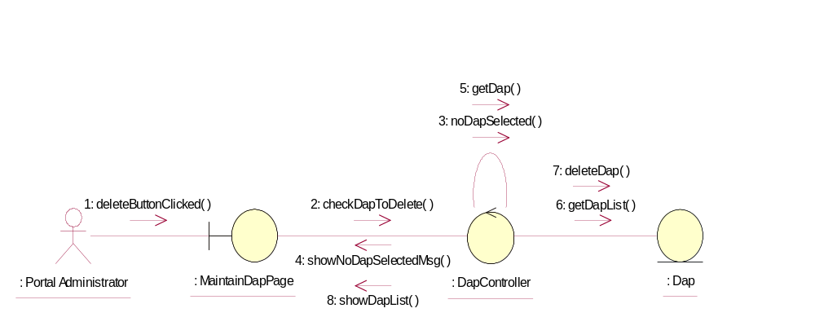

Participating Objects
: Dap
This Entity is Dap object

: DapController
This controller is to add, delete and update Dap

: MaintainDapPage
This is a page for adding, deleting, updating and displaying Dap

: Portal Administrator
This is the super user of the system.

Class Diagrams

Class Diagram for Delete Dap
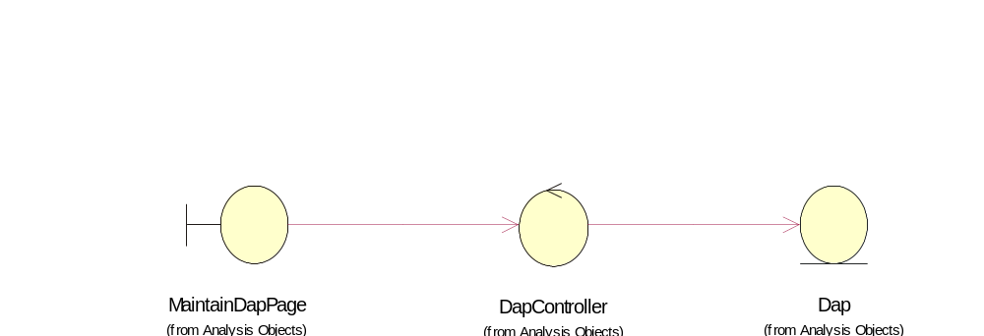

Derived Requirements
Only Portal Administrator has rights to access this page.

